|  |
| --- |
| **A CRM Application to Manage the Services offered by an Institution** |

# 

## Table of Contents

1. Project Overview
2. Project Objectives
3. Scope of Work
4. System Architecture
5. Implementation Strategy
6. User Roles and Responsibilities
7. Reporting and Dashboards
8. Data Migration
9. Training Plan

10.Risks and Mitigation

11.Project Timeline

12.Budget and Resources

13.Appendix

## 1. Project Overview

**Project Name:** A CRM Application to Manage the Services offered by an Institution

### 1.1 Background

EduConsultPro Institute is a leading educational institution that offers a wide range of courses and programs in various fields. The institute is experiencing a rapid increase in the number of prospective students seeking admission each year. This growth has led to challenges in managing the admission process, handling student inquiries, and providing expert consulting services. To address these challenges, EduConsultPro Institute has decided to implement a Salesforce CRM system to streamline these processes and improve the overall experience for both students and staff.

### 1.2 Purpose

The purpose of this project is to develop and implement a Salesforce CRM solution that will help EduConsultPro Institute manage its admission process, student inquiries, and consulting services more efficiently. The CRM will also provide insights through reporting and analytics, enabling the institution to make data-driven decisions.

### 1.3 Goals

* Streamline the admission process for prospective students.
* Improve the efficiency of handling student inquiries.
* Enhance the management of expert consulting services.
* Provide detailed reporting and analytics to support decision-making.

## 2. Project Objectives

### 2.1 Admission Process Management

* Automate the submission and review process for admission applications.
* Create custom workflows and approval processes for application review.
* Enable easy tracking of student applications and their statuses.

### 2.2 Student Inquiry Management

* Capture and manage inquiries from prospective students using web-to-lead forms.
* Automate responses to inquiries and provide timely follow-ups.
* Track the status and resolution of all inquiries.

### 2.3 Case Management for Consulting Services

* Implement a case management system to handle student and faculty queries.
* Use email-to-case functionality to automatically create cases from emails.
* Develop a knowledge base for resolving common issues.

### 2.4 Reporting and Analytics

* Create dashboards to track key metrics related to admissions, inquiries, and cases.
* Generate reports to analyze trends and identify areas for improvement.
* Provide insights to support strategic decision-making.

## 3. Scope of Work

### 3.1 Functional Requirements

* **Admission Process Management:**
  + Custom objects for Application, Course, and Application Status.
  + Automated workflows for application submission, review, and approval.
  + User interfaces for staff to review and manage applications.
* **Student Inquiry Management:**
  + Web-to-lead forms for capturing student inquiries.
  + Automated email responses and notifications.
  + Dashboards for tracking inquiries and their statuses.
* **Case Management for Consulting Services:**
  + Custom case objects and workflows for managing queries.
  + Email-to-case setup for creating cases from incoming emails.
  + Knowledge base for storing and retrieving solutions to common issues.

### 3.2 Non-Functional Requirements

* **Scalability:** The system should be able to handle an increasing number of users and data as the institution grows.
* **Performance:** The CRM should perform efficiently with minimal latency.
* **Security:** Implement robust security measures, including role-based access, encryption, and data protection.
* **Usability:** The CRM should be user-friendly, with intuitive interfaces and easy navigation.

### 3.3 Out of Scope

* Development of mobile applications.
* Integration with third-party systems not directly related to admissions, inquiries, or case management.

## 4. System Architecture

### 4.1 Salesforce Objects

* **Course Object:**

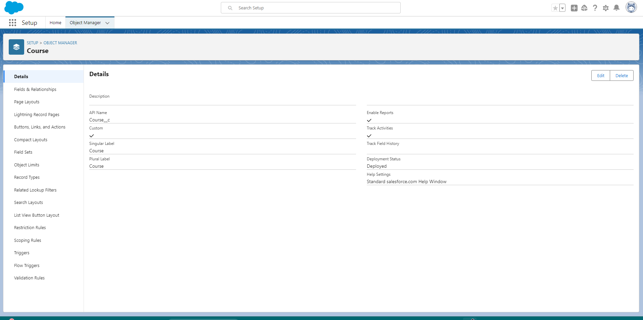

**Consultant Object:**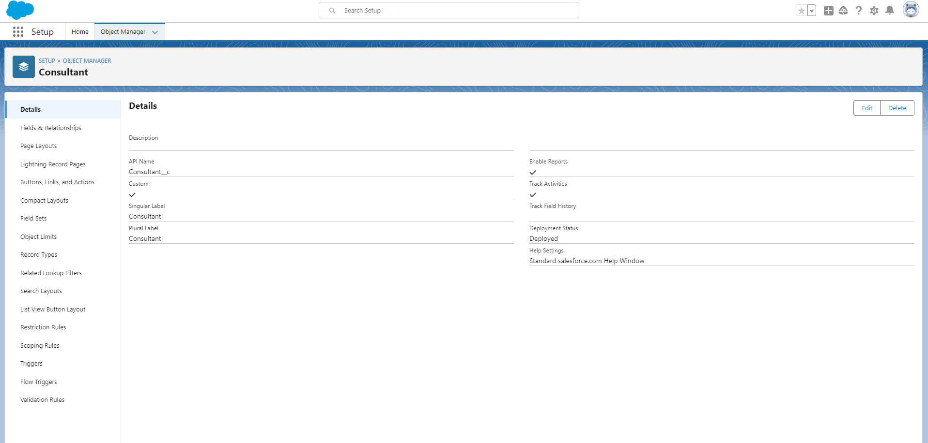

**Subject Object:**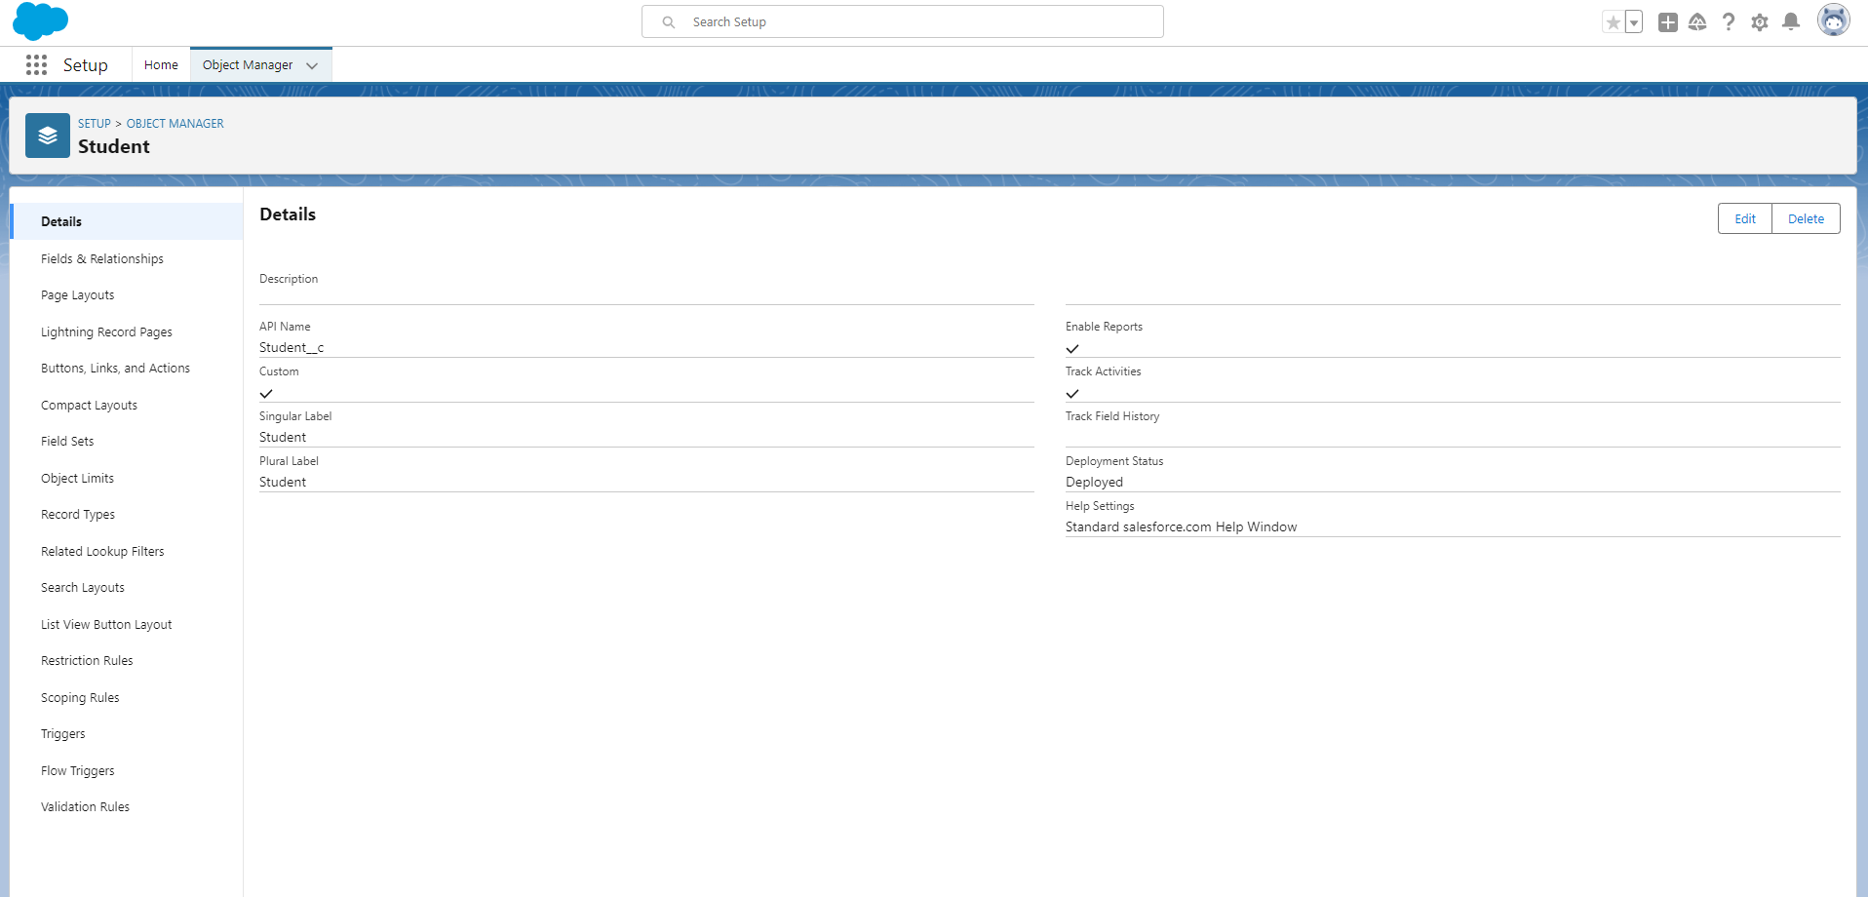

**Appointment Object**:

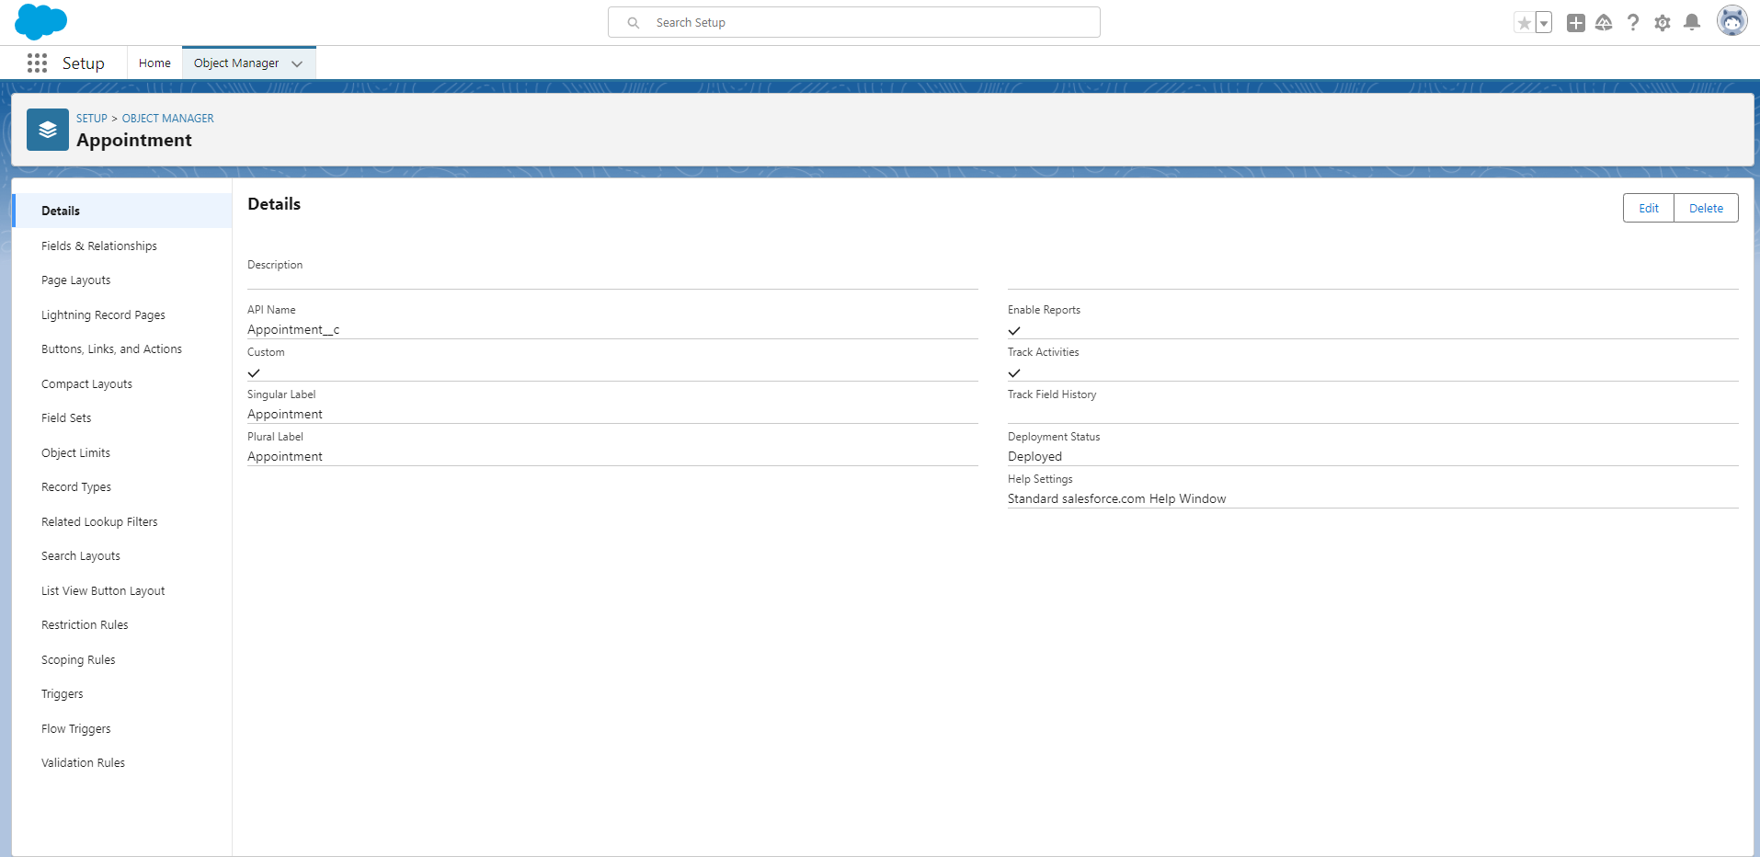

### 4.2 Data Model

The data model includes relationships between custom and standard objects. For example:

* **Course Field:**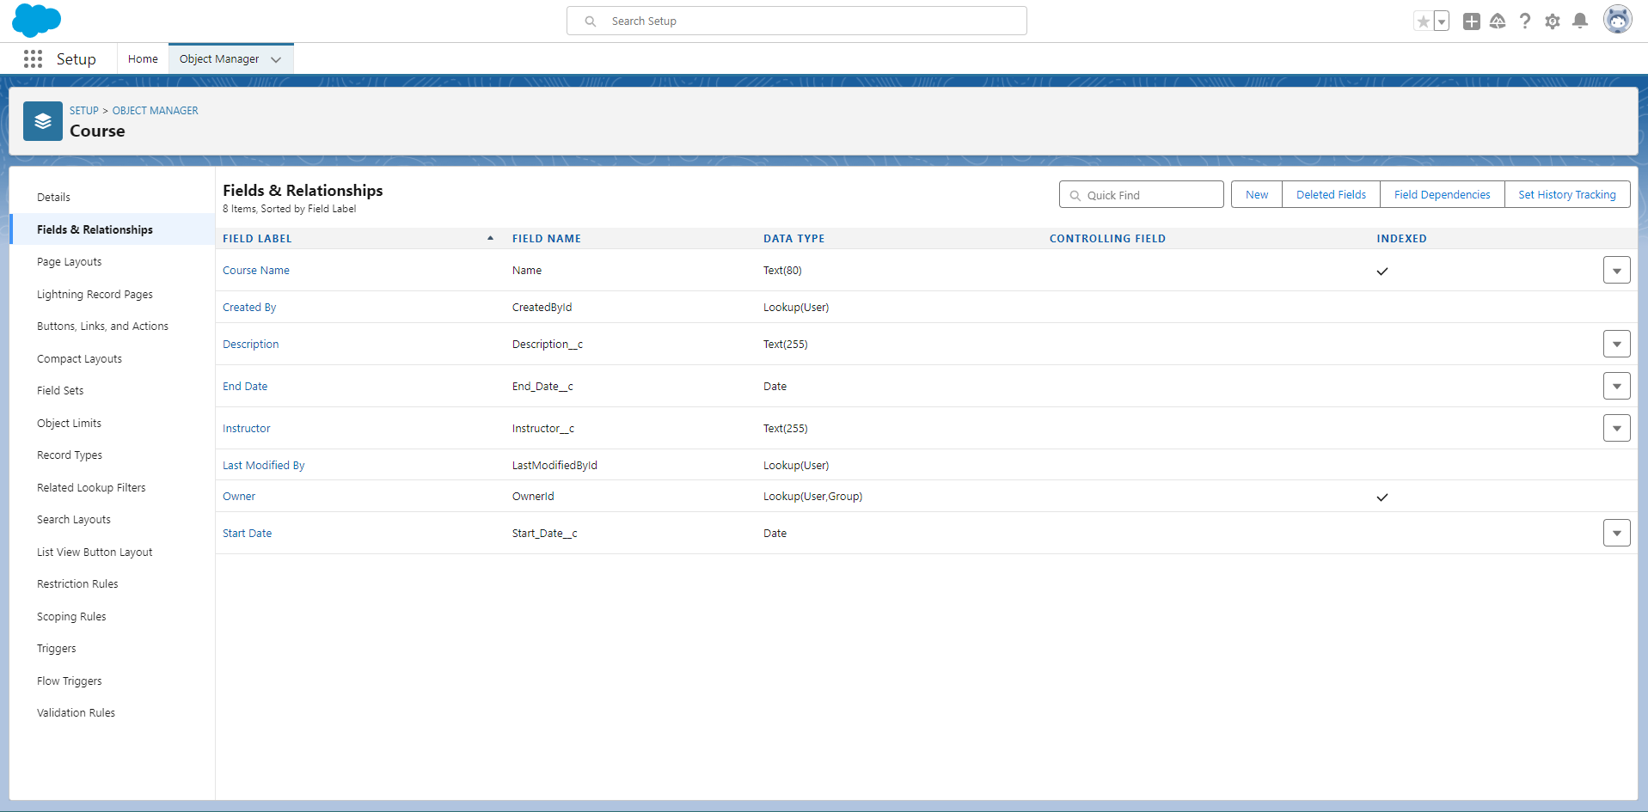

**Consultant Field:**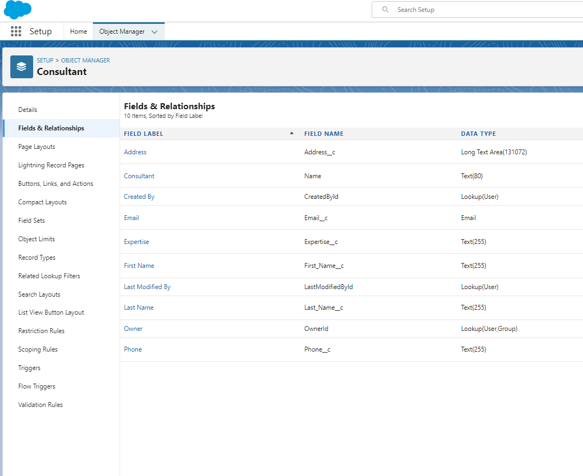

**Student Field:**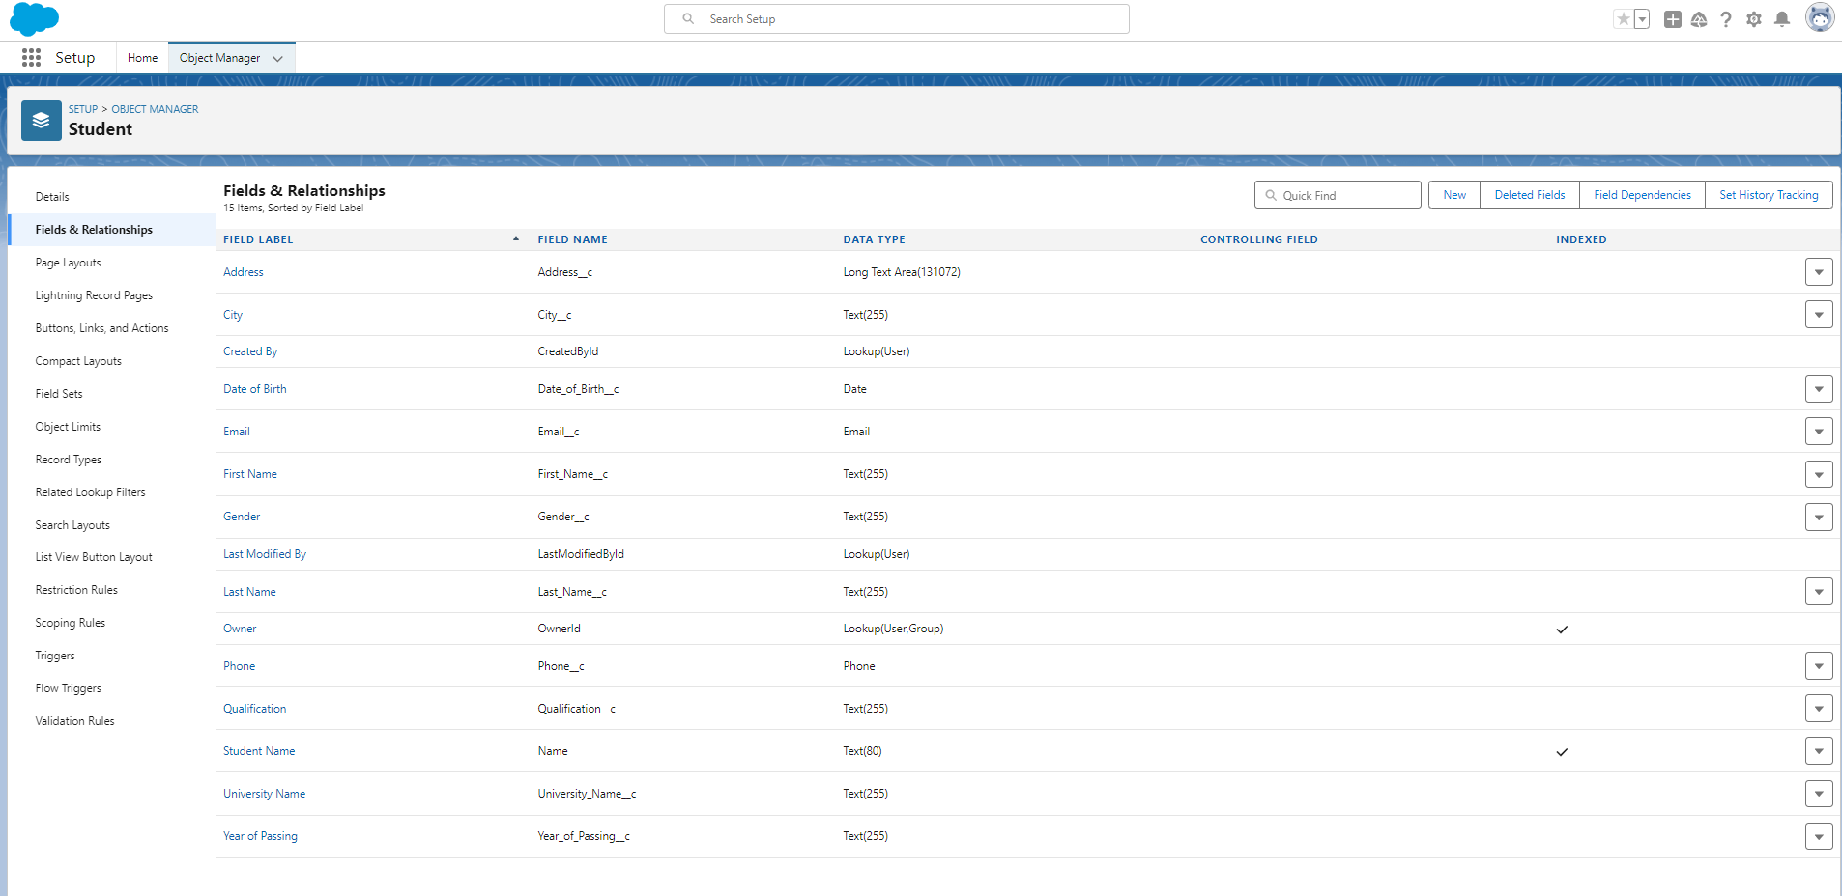

**Appoitment Field:**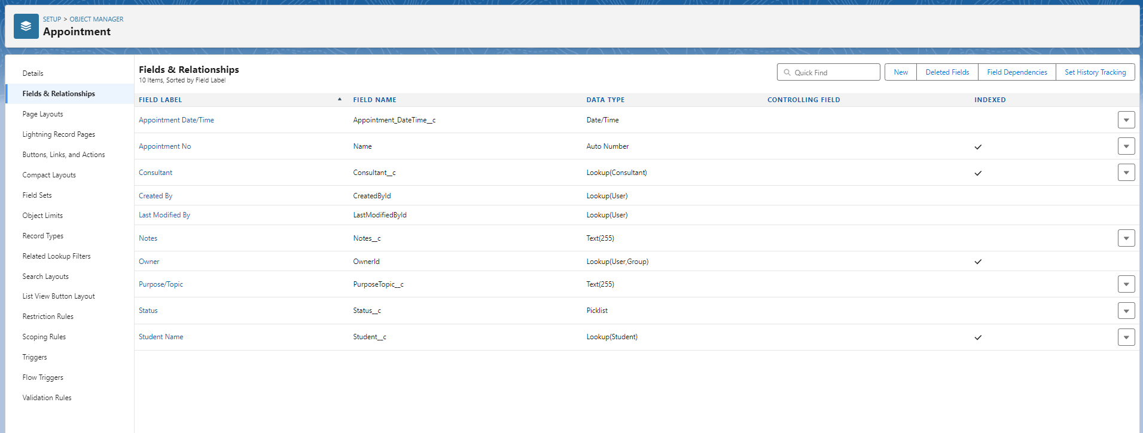

### 4.3 App Manager

### **App details and branding:**

**Navigation Items:**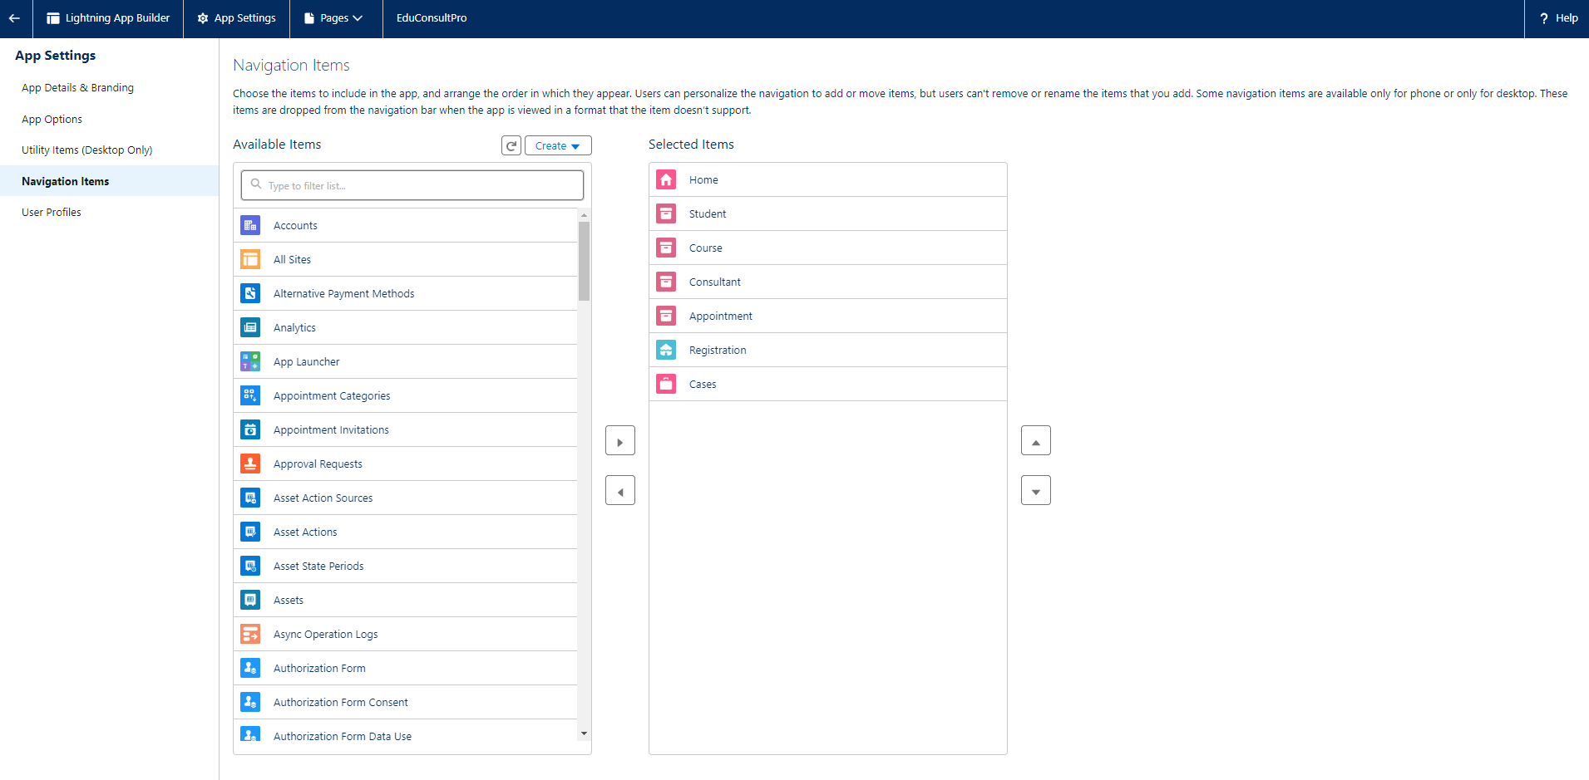

### **User profile:**

### 4.4 Automation

### **Flow:**

**Flow:**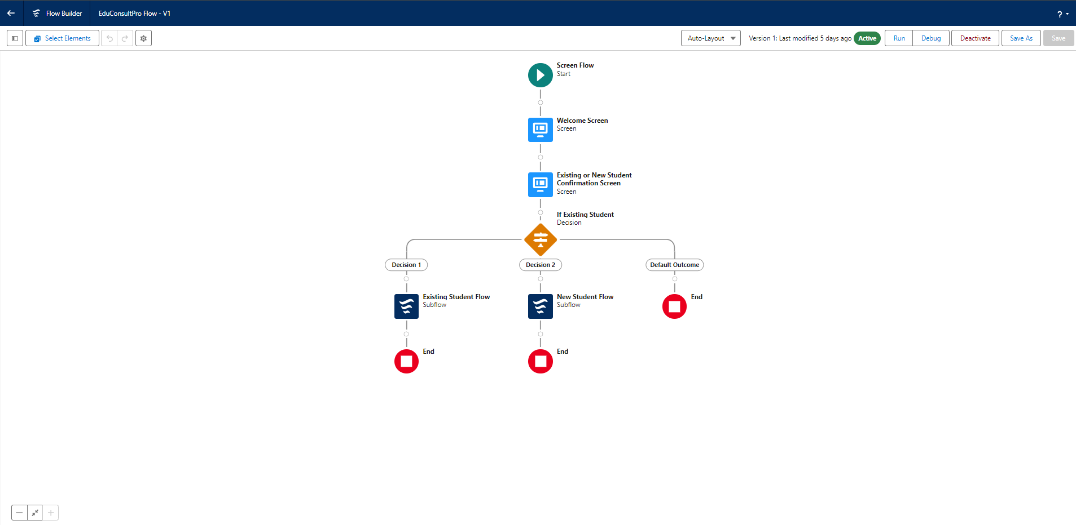

**Student flow:**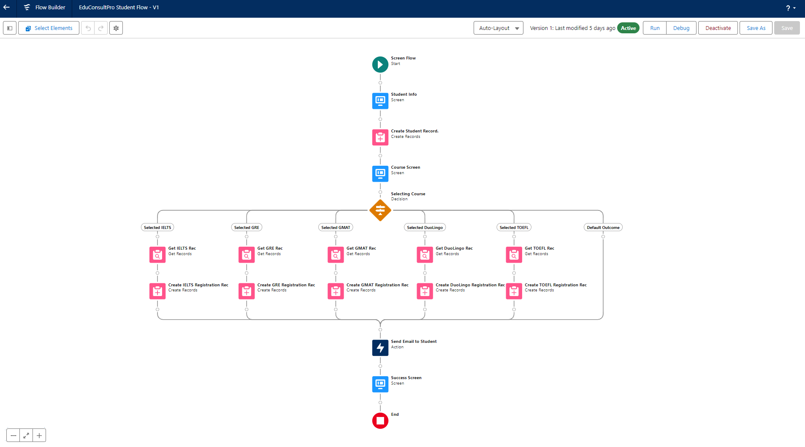

**Approval flow:**

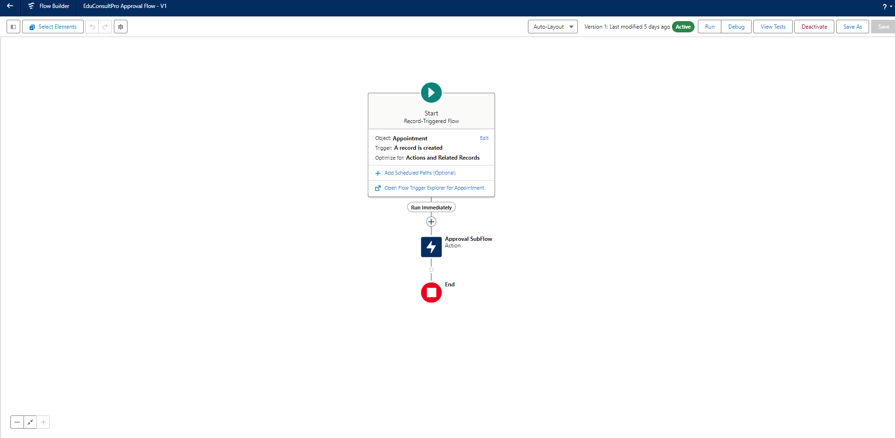

**Exsiting Student flow:**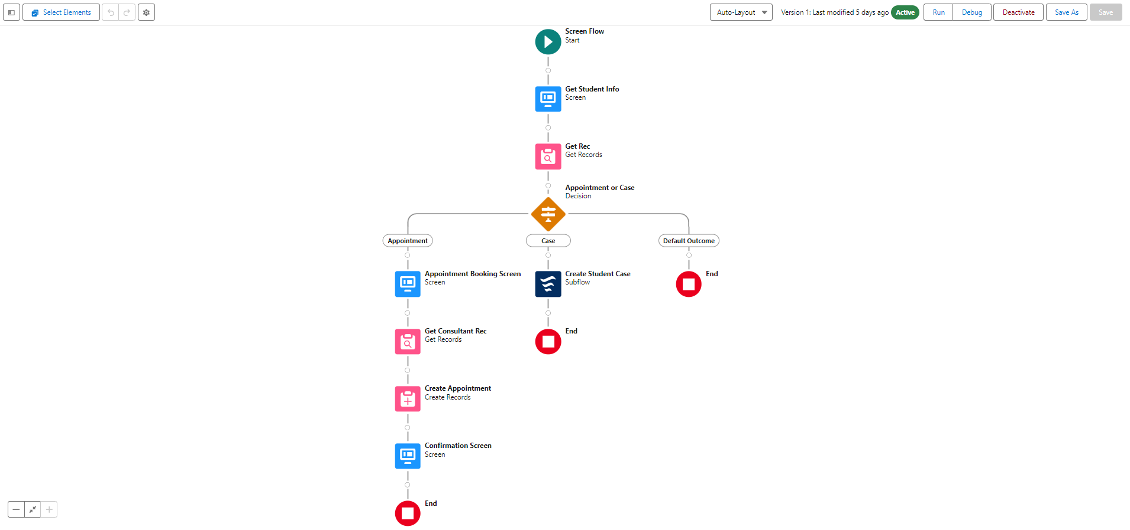

### 4.5 User

### **Users:**

**4.6 Email Templates**

**All templates:**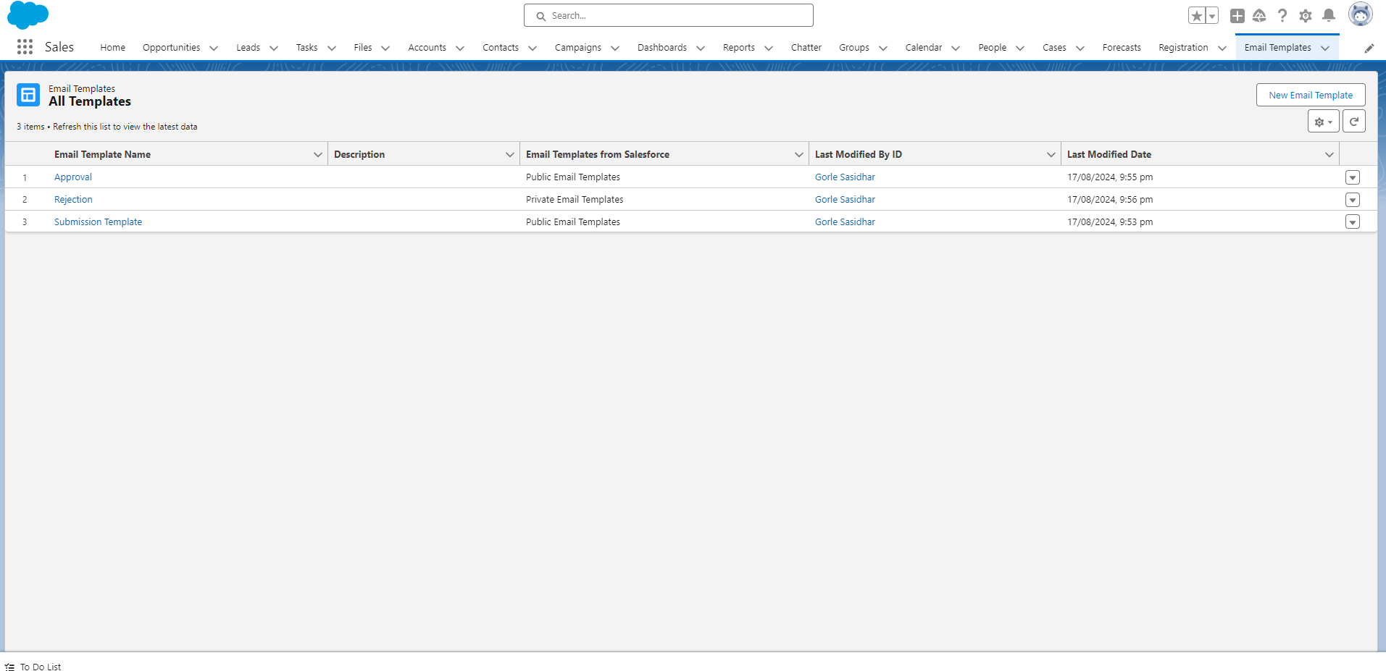

**Approval Process:**

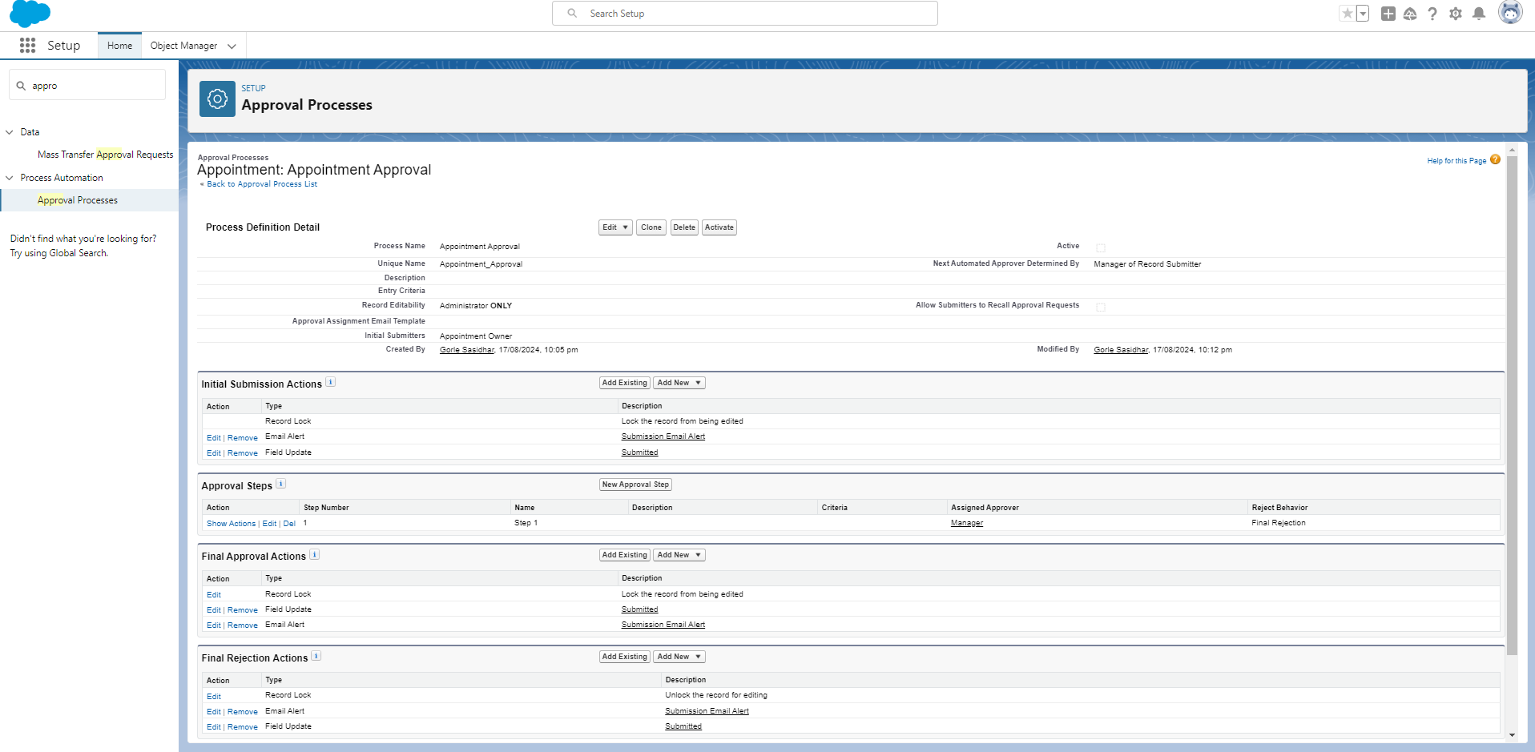

**4.7 Lightning App builder(output):**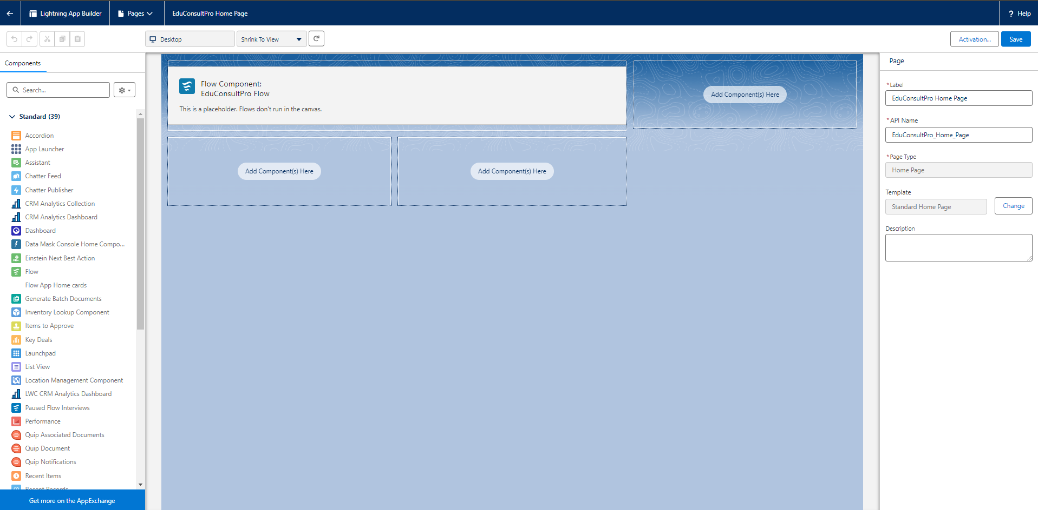

## 5. Implementation Strategy

### 5.1 Phase 1: Requirement Gathering

* Conduct workshops with EduConsultPro staff to gather detailed requirements.
* Document use cases and business processes.
* Identify key stakeholders and their needs.

### 5.2 Phase 2: System Design

* Design the data model and process flows based on requirements.
* Develop mock-ups for user interfaces, forms, and dashboards.
* Define the security model, including roles, profiles, and sharing rules.

### 5.3 Phase 3: Development

* Customize Salesforce to create the required objects, fields, and workflows.
* Develop custom Apex code, triggers, and Visualforce pages as needed.
* Configure automation tools like Process Builder and Flow.
* Implement integrations with external systems, such as email and web-to-lead forms.

### 5.4 Phase 4: Testing

* **Unit Testing:** Test individual components, such as custom objects and workflows, to ensure they function correctly.
* **Integration Testing:** Test the interactions between different components and external systems.
* **User Acceptance Testing (UAT):** Conduct UAT sessions with EduConsultPro staff to validate the system against business requirements.

### 5.5 Phase 5: Deployment

* Deploy the final configuration and customizations to the production environment.
* Migrate data from existing systems into Salesforce.
* Set up monitoring tools to track system performance and user activity.

### 5.6 Phase 6: Post-Deployment Support

* Provide ongoing support to address any issues that arise after deployment.
* Monitor system performance and make necessary adjustments.
* Offer training sessions and resources to help users get the most out of the CRM.

## 6. User Roles and Responsibilities

### 6.1 Admissions Staff

* **Responsibilities:**
  + Review and process admission applications.
  + Manage student inquiries.
  + Update student records and application statuses.
  + Generate reports on admission metrics.
* **Salesforce Features Used:**
  + Custom objects for Applications and Inquiries.
  + Dashboards and reports.
  + Approval processes for application reviews.

### 6.2 Salesforce Admin

* **Responsibilities:**
  + Manage user access, profiles, and permissions.
  + Monitor system health and performance.
  + Configure and maintain custom objects, workflows, and automation tools.
  + Provide technical support to other users.
* **Salesforce Features Used:**
  + Setup and configuration tools.
  + Security settings, roles, and profiles.
  + Data management tools.

### 6.3 Salesforce Developer

* **Responsibilities:**
  + Develop custom solutions using Apex, Visualforce, and Lightning components.
  + Implement complex business logic and integrations.
  + Work with the admin to customize the CRM based on business requirements.
* **Salesforce Features Used:**
  + Apex code, triggers, and classes.
  + Visualforce pages and Lightning components.
  + Integration tools and APIs.

### 6.4 Case Manager

* **Responsibilities:**
  + Handle student and faculty queries.
  + Track and resolve cases efficiently.
  + Update the knowledge base with new solutions.
* **Salesforce Features Used:**
  + Case management tools.
  + Email-to-case functionality.
  + Knowledge base and article management.

## 7. Reporting and Dashboards

### 7.1 Admission Process Reports

* **Metrics Tracked:**
  + Number of applications submitted, reviewed, and approved.
  + Average time to process an application.
  + Conversion rate of applications to enrollments.
* **Sample Reports:**
  + **Application Status Report:** Breaks down the number of applications by status (e.g., Pending, Approved, Rejected).
  + **Admissions Overview Dashboard:** Visual summary of key admission metrics.

### 7.2 Inquiry Management Dashboard

* **Metrics Tracked:**
  + Number of inquiries received by channel (e.g., web, email).
  + Response time to inquiries.
  + Resolution time for inquiries.
* **Sample Reports:**
  + **Inquiry Source Report:** Shows the distribution of inquiries by source (e.g., website, email).
  + **Inquiry Resolution Time Report:** Tracks the time taken to resolve inquiries.

### 7.3 Case Management Reports

* **Metrics Tracked:**
  + Number of cases opened, resolved, and pending.
  + Average case resolution time.
  + Common issues and their frequency.
* **Sample Reports:**
  + **Case Status Report:** Displays the number of cases by status (e.g., New, In Progress, Resolved).
  + **Case Resolution Dashboard:** Provides insights into case resolution times and common issues.

## 8. Data Migration

### 8.1 Data Sources

* **Existing Systems:** Identify the current systems where student and course data are stored.
* **Data Types:** Determine the types of data to be migrated, such as student records, course details, and application histories.

### 8.2 Data Mapping

* **Mapping Plan:** Map fields from existing systems to Salesforce objects and fields.
* **Field Matching:** Ensure data consistency by matching fields accurately between source and target systems.

### 8.3 Data Migration Plan

* **Pre-Migration Steps:**
  + Backup existing data.
  + Cleanse data to remove duplicates and inaccuracies.
  + Validate data integrity.
* **Migration Execution:**
  + Use Salesforce Data Loader or other ETL tools to import data into Salesforce.
  + Migrate data in phases, starting with test data and moving to full-scale migration.
* **Post-Migration Validation:**
  + Validate migrated data for accuracy and completeness.
  + Perform reconciliation to ensure data integrity.
  + Update mappings or configurations as needed.

## 9. Training Plan

### 9.1 Training Objectives

* Ensure users are comfortable with the Salesforce CRM system.
* Provide hands-on experience with key features and workflows.
* Facilitate user adoption by addressing common concerns and challenges.

### 9.2 Training Sessions

* **Session 1: Introduction to Salesforce CRM**
  + Overview of the Salesforce platform.
  + Basic navigation and user interface.
* **Session 2: Admissions Process Management**
  + How to create, review, and manage applications.
  + Using dashboards and reports to track admissions.
* **Session 3: Inquiry Management**
  + Capturing and managing student inquiries.
  + Automating responses and follow-ups.
* **Session 4: Case Management**
  + Handling student and faculty queries.
  + Using the knowledge base and resolving cases.

### 9.3 Training Resources

* **User Manuals:** Detailed guides on how to use each feature.
* **Video Tutorials:** Step-by-step video instructions for key tasks.
* **Q&A Sessions:** Live sessions where users can ask questions and get answers.

### 9.4 Post-Training Support

* **Help Desk:** Provide ongoing support through a dedicated help desk.
* **Follow-Up Sessions:** Schedule follow-up training sessions to address any issues or questions.

## 10. Risks and Mitigation

### 10.1 Data Migration Risk

* **Risk:** Data migration may lead to data loss or corruption.
* **Mitigation:** Conduct thorough testing and validation of data before and after migration. Backup all data before starting the migration process.

### 10.2 User Adoption Risk

* **Risk:** Users may resist adopting the new system.
* **Mitigation:** Provide comprehensive training and support to ease the transition. Gather user feedback and make adjustments based on their input.

### 10.3 System Downtime

* **Risk:** The system may experience downtime during deployment or post-deployment.
* **Mitigation:** Schedule deployments during off-peak hours and ensure backup and recovery plans are in place.

### 10.4 Integration Issues

* **Risk:** Integration with existing systems may cause conflicts or data discrepancies.
* **Mitigation:** Thoroughly test all integrations in a sandbox environment before deploying them to production.

## 11. Project Timeline

### 11.1 Milestones

1. **Requirement Gathering (Weeks 1-2)**
   * Workshops with stakeholders.
   * Documentation of use cases.
2. **System Design (Weeks 3-4)**
   * Data model design.
   * Security model setup.
3. **Development (Weeks 5-8)**
   * Customization of Salesforce.
   * Development of custom code and workflows.
4. **Testing (Weeks 9-10)**
   * Unit testing.
   * User acceptance testing (UAT).
5. **Deployment (Week 11)**
   * Migration to production.
   * Go-live.
6. **Post-Deployment Support (Week 12)**
   * Ongoing support and system monitoring.
   * Final training sessions.

### 11.2 Gantt Chart

* **Week 1-2:** Requirement Gathering
* **Week 3-4:** System Design
* **Week 5-8:** Development
* **Week 9-10:** Testing
* **Week 11:** Deployment
* **Week 12:** Post-Deployment Support

(Include a visual Gantt chart here)

## 12. Budget and Resources

### 12.1 Estimated Budget

* **Software Licenses:** $[Amount]
* **Development Costs:** $[Amount]
* **Training Costs:** $[Amount]
* **Contingency:** $[Amount]
* **Total Estimated Budget:** $[Total Amount]

### 12.2 Resource Allocation

* **Salesforce Licenses:** [Number of licenses]
* **Development Tools:** [List of tools and software required]
* **Team Members:** [Number of team members and their roles]

### 12.3 Budget Breakdown

(Include a detailed breakdown of costs by category)

## 13. Appendix

### 13.1 Glossary of Terms

* **CRM:** Customer Relationship Management.
* **UAT:** User Acceptance Testing.
* **ETL:** Extract, Transform, Load.
* **ERD:** Entity-Relationship Diagram.

### 13.2 System Diagrams

* **ERD Diagram:** Visual representation of the data model.
* **Process Flow Diagrams:** Diagrams illustrating key business processes.

### 13.3 User Manuals and Guides

* **Admissions Staff Manual:** Detailed guide for managing the admissions process.
* **Inquiry Management Guide:** Instructions for handling student inquiries.
* **Case Management Guide:** Step-by-step guide for managing cases.